

Self Start Body Smart at Marcotte Physiotherapy

Assignment Workbook

Winter 2017

Revision History

|  |  |  |  |  |
| --- | --- | --- | --- | --- |
| **Date** | **Time** | **Issue** | **Description** | **Author** |
| 06/12/2017 |  | Fall 2017 | Final E-R Diagram Created | Leo Zhang, Sooruj Ghangass, Tomiwa Ademidun, Andrew Hart, Nicholas Vukelic, Brian He |
| 06/12/2017 |  | Fall 2017 | Final Report Created – All Sections | Leo Zhang, Sooruj Ghangass, Tomiwa Ademidun, Andrew Hart, Nicholas Vukelic, Brian He |
| 24/01/2018 | 8:00 pm | Winter 2018 | Created the routes for all entities | Tharmiga Loganathan, Brian He, Leo Zhang |
| 24/01/2018 | 7:00pm | Winter 2018 | Created the schemas/models for all entities | Sooruj Ghangass, Nicholas Vukelic, Andrew Hart |
| 24/01/2018 | 9:00pm | Winter 2018 | Created the node server | Tharmiga Loganathan |
| 25/01/2018 | 5:00pm | Winter 2018 | Update SDS based on provided schema and the up-to-date back-end | Nicholas Vukelic, Andrew Hart |
| 25/01/2018 – 29/01/2018 | Various | Winter 2018 | Overall code editing for consistency between schemas & routes | All |
| 29/01/2018 | 8:30pm | Winter 2018 | Updated the SDS as per Ouda’s new instructions today | Nicholas Vukelic |
| 05/03/2018 | 9:30pm | Winter 2018 | Update SDS to reflect Lab 3 progress | Andrew Hart |
| 19/03/2018 | 9:30pm | Winter 2018 | Update SDS to reflect Lab 4 progress | Andrew Hart |
| 04/04/2018 | 11:00pm | Winter 2018 | Update SDS to reflect Lab 5 progress | Nick Vukelic |

Table of Contents

Potential Entity Classes 4

Classes Attributes 5

Entity Class Diagram 9

# Potential Entity Classes

|  |  |
| --- | --- |
| Class name | Brief Description |
| User Account | Securely stores the username and encrypted password for each user of the system. |
| SelfStart User | Encapsulates common characteristics among all users. In practice, it is not implemented as a class since it is inherited by classes through a “mandatory, or” relationship. |
| Administrator | Stores specific information for Administrator users. |
| Physiotherapist | Stores specific information for Physiotherapist users. |
| Patient Profile | Stores specific information for Patient users. |
| Forms | Stores information related to each form, such as name and description. |
| Questions | Stores information related to each question, such as the question order and help description. |
| Question Type | Stores the question type for each question. |
| Assessment Tests | Stores information related to each of the assessment tests, including name, author, and description. |
| Test Result | Stores the result of each assessment test. |
| Rehabilitation Plans | Stores information related to the rehabilitation plan, such as name, description, author, goal, and time frame. |
| Exercises | Stores information for each exercise, such as name, description, and multimedia link. |
| Recommendation | Stores information for the recommendations of each assessment test, including the decision made by the physiotherapist. |
| Treatments | Stores the information related to each treatment, such as the assigned date. |
| Payments | Stores the information related to a payment by a patient user, such as amount and note. |
| Country | Stores a list of country names. |
| Province | Stores a list of provinces associated to each country. |
| City | Stores a city for the location of each patient user. |
| Gender | Stores the gender for the patient. |
| Appointment | Stores information related to an appointment the patient has made with the office. |
| Message | Stores information related to conversations between patients and physiotherapists. |

# Classes Attributes

1. ***User* *Account***

|  |  |  |
| --- | --- | --- |
| **Attribute name** | **Type** | **Brief Description** |
| userAccountName | String | Account name of the user |
| encryptedPassword | String | Encrypted password of the user |

1. ***SelfStart User***

|  |  |  |
| --- | --- | --- |
| **Attribute name** | **Type** | **Brief Description** |
| ID | String | Unique id of the user |
| familyName | String | Last name of the user |
| givenName | String | First name of the user |
| email | String | Email of the user |

1. ***Administrator***

|  |  |  |
| --- | --- | --- |
| **Attribute name** | **Type** | **Brief Description** |
| dateHired | Date | Date hired |
| dateFinished | Date | Date finished |

1. ***Physiotherapist***

|  |  |  |
| --- | --- | --- |
| **Attribute name** | **Type** | **Brief Description** |
| dateHired | Date | Date hired |
| dateFinished | Date | Date finished |

1. ***Patient Profile***

|  |  |  |
| --- | --- | --- |
| Attribute name | Type | Brief Description |
| DOB | Date | DOB of the patient |
| postalCode | String | Postal code of the patient |
| phone | String | Phone number of the patient |
| others | String | Other information about the patient |

1. ***Forms***

|  |  |  |
| --- | --- | --- |
| **Attribute name** | **Type** | **Brief Description** |
| name | String | Name of the form |
| description | String | Description of the form |
| type | String | Form type |

1. ***Questions***

|  |  |  |
| --- | --- | --- |
| **Attribute name** | **Type** | **Brief Description** |
| questionText | String | Question information |
| helpDescription | String | Additional information about question |
| questionType | String | Type of question |
| answerChoices | String | List of possible answers |
| range | Number | Numerical range of answers |
| type | String | Question type (E.g. short answer, multiple choice etc.) |

1. ***Question Type***

|  |  |  |
| --- | --- | --- |
| **Attribute name** | **Type** | **Brief Description** |
| name | String | Category of the question |

1. ***Assessment Test***

|  |  |  |
| --- | --- | --- |
| **Attribute name** | **Type** | **Brief Description** |
| name | String | Name of the assessment test |
| description | String | Description of the assessment test |
| authorName | String | Name of the assessment test author |
| openDate | Date | Date of creation by physiotherapist |
| dateCompleted | Date | Date of completion by patient |
| recommendationDecision | String | Description of the recommendation |
| recommendationEvaluation | Number | A 1 to 10 rating on the effectiveness of the rehab plan |

1. ***Test Result***

|  |  |  |
| --- | --- | --- |
| **Attribute name** | **Type** | **Brief Description** |
| question | String | Question information |
| answer | String | Response information |

1. ***Rehabilitation Plans***

|  |  |  |
| --- | --- | --- |
| **Attribute name** | **Type** | **Brief Description** |
| name | String | Name of the rehabilitation plan |
| description | String | Description of the rehabilitation plan |
| authorName | String | Name of the rehabilitation plans author |
| goal | String | End goal of the rehabilitation plan |
| timeFrameToComplete | String | Period of time to complete the rehabilitation plan |
| custom | Boolean | Flag to differentiate custom and standard rehabilitation plans |
| startDate | Date | Date this rehab plan opened |
| endDate | Date | Date this rehab plan closed |

1. ***Exercises***

|  |  |  |
| --- | --- | --- |
| **Attribute name** | **Type** | **Brief Description** |
| name | String | Name of the exercise |
| description | String | Description of the exercise |
| objectives | String | Objectives of the exercise |
| authorName | String | Author of the exercise |
| actionSteps | String | Steps taken to complete the exercise |
| location | String | Location of the exercise |
| frequency | Int | Frequency of the exercise |
| duration | Double | Length of time to complete exercise |
| targetDate | Date | Date to finish exercise |
| multimediaURL | String | URL of multimedia link |
| standard | Boolean | Flag to differentiate standard and custom exercises |

1. ***Recommendation***

|  |  |  |
| --- | --- | --- |
| **Attribute name** | **Type** | **Brief Description** |
| timeStamp | Date | Timestamp of recommendation occurrence |
| decision | String | Recommendation details and instructions |

1. ***Treatments***

|  |  |  |
| --- | --- | --- |
| **Attribute name** | **Type** | **Brief Description** |
| dateAssign | Date | Date of treatment assignment |
| dateStart | Date | Date of treatment start |

1. ***Payments***

|  |  |  |
| --- | --- | --- |
| **Attribute name** | **Type** | **Brief Description** |
| dayTimeStamp | Date | Transaction timestamp |
| amount | Double | Transaction amount |
| note | String | Additional information |

1. ***Country***

|  |  |  |
| --- | --- | --- |
| **Attribute name** | **Type** | **Brief Description** |
| name | String | Name of the country |

1. ***Province***

|  |  |  |
| --- | --- | --- |
| **Attribute name** | **Type** | **Brief Description** |
| name | String | Name of the province/territory/state |

1. ***City***

|  |  |  |
| --- | --- | --- |
| **Attribute name** | **Type** | **Brief Description** |
| name | String | Name of the city |

1. ***Gender***

|  |  |  |
| --- | --- | --- |
| **Attribute name** | **Type** | **Brief Description** |
| name | String | Name of the gender, if the patient has chosen to disclose their gender |

1. ***Appointment***

|  |  |  |
| --- | --- | --- |
| **Attribute name** | **Type** | **Brief Description** |
| date | Date | Date of appointment, including time |
| reason | String | Reason for the appointment, as indicated by the patient |
| other | String | Other notes associated with the Appointment, as indicated by the patient |
| endDate | Date | Appointment end time |

1. ***Message***

|  |  |  |
| --- | --- | --- |
| **Attribute name** | **Type** | **Brief Description** |
| patientID | String | Unique id of the patient |
| physioID | String | Unique id of the physiotherapist |
| message | String | Message content |
| seenByPhysio | Boolean | Flag to differentiate between seen and unseen messages |
| seenByPhysio | Boolean | Flag to differentiate between seen and unseen messages |
| sender | String | Unique id of the message sender |
| time | Date | Send time |

# Entity Class Diagram

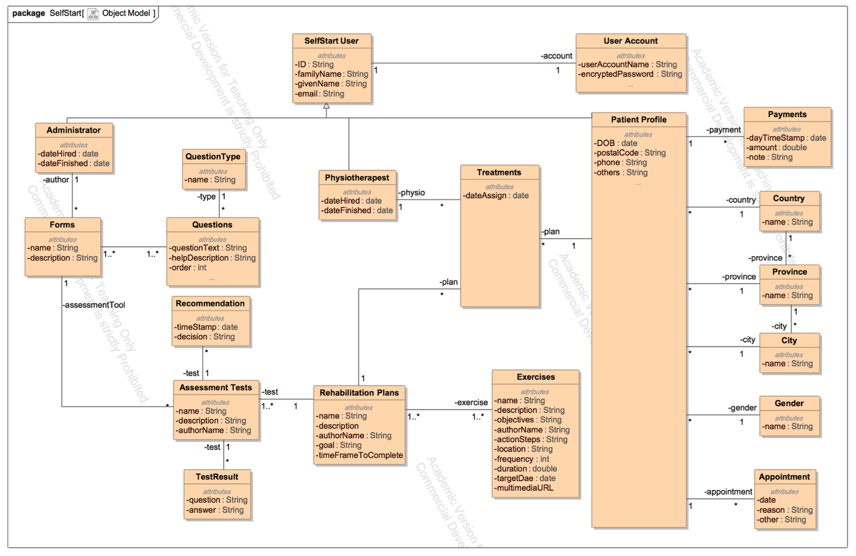

The class diagram above is the same as the database schema for the system. It describes the relationship between all separate entities in the system in a structured way. It has guided the development of the back-end system, where there are the appropriate routes in place to create, update, delete, and get each of the corresponding entities.

**Important:**

Please note that ExerciseOrder and QuestionOrder are both models in our database, but both can be ignored, as neither are being used. Also note, that after discussion with Dan, we have removed the redundant association between Treatments and Recommendations in the Entity Class Diagram. We have also added a new model called Message, which stores information pertaining to conversations between patients and physiotherapists.